Hands-on 9 - Delete a country based on code

Name: Shubham Sangram Bej

Aim
To delete a country from the database using Spring Data JPA.

Theory
Spring Data JPA provides the deleteById() method to remove an entity using its primary key. The operation is managed within a transaction using the @Transactional annotation.

Procedure
- Create deleteCountry() method.
- Invoke deleteById().
- Execute the method from the application.
- Verify deletion in MySQL.

Screenshots
CountryService.java

package com.cognizant.ormlearn.service;
import com.cognizant.ormlearn.model.Country;
import com.cognizant.ormlearn.repository.CountryRepository;
import org.springframework.beans.factory.annotation.Autowired;
import org.springframework.stereotype.Service;
import org.springframework.transaction.annotation.Transactional;
import java.util.Optional;
import com.cognizant.ormlearn.service.exception.CountryNotFoundException;
import java.util.List;
@Service
public class CountryService {
@Autowired
private CountryRepository countryRepository;
@Transactional
public List<Country> getAllCountries() {
return countryRepository.findAll();
}
@Transactional
public Country findCountryByCode(String countryCode) throws CountryNotFoundException {
Optional<Country> result = countryRepository.findById(countryCode);
if (!result.isPresent()) {
throw new CountryNotFoundException("Country not found with code: " + countryCode);
}
Country country = result.get();
return country;
}
@Transactional
public void addCountry(Country country) {
countryRepository.save(country);
}
@Transactional
public void updateCountry(String code, String name)
throws CountryNotFoundException {
Country country = findCountryByCode(code);
country.setName(name);
countryRepository.save(country);
}
@Transactional
public void deleteCountry(String code) {
countryRepository.deleteById(code);
}
}

OrmLearnApplication.java

package com.cognizant.ormlearn;
import com.cognizant.ormlearn.model.Country;
import com.cognizant.ormlearn.service.CountryService;
import org.slf4j.Logger;
import org.slf4j.LoggerFactory;
import org.springframework.boot.SpringApplication;
import org.springframework.boot.autoconfigure.SpringBootApplication;
import org.springframework.context.ApplicationContext;
import java.util.List;
@SpringBootApplication
public class OrmLearnApplication {
private static final Logger LOGGER =
LoggerFactory.getLogger(OrmLearnApplication.class);
private static CountryService countryService;
public static void main(String[] args) {
ApplicationContext context = SpringApplication.run(OrmLearnApplication.class, args);
LOGGER.info("Inside main");
countryService = context.getBean(CountryService.class);
testGetAllCountries();
testFindCountryByCode();
testAddCountry();
testUpdateCountry();
testDeleteCountry();
}
private static void testGetAllCountries() {
LOGGER.info("Start");
List<Country> countries = countryService.getAllCountries();
LOGGER.debug("countries={}", countries);
LOGGER.info("End");
}
private static void testFindCountryByCode() {
LOGGER.info("Start");
try {
Country country = countryService.findCountryByCode("PT");
LOGGER.debug("Country={}", country);
} catch (Exception e) {
LOGGER.error(e.getMessage());
}
LOGGER.info("End");
}
private static void testAddCountry() {
LOGGER.info("Start");
Country country = new Country();
country.setCode("ZZ");
country.setName("Shubham's Land");
countryService.addCountry(country);
try {
Country addedCountry = countryService.findCountryByCode("ZZ");
LOGGER.debug("Added Country={}", addedCountry);
} catch (Exception e) {
LOGGER.error(e.getMessage());
}
LOGGER.info("End");
}
private static void testUpdateCountry() {
LOGGER.info("Start");
try {
countryService.updateCountry("ZZ", "Shubham & Co's Country");
Country country = countryService.findCountryByCode("ZZ");
LOGGER.debug("Updated Country={}", country);
} catch (Exception e) {
LOGGER.error(e.getMessage());
}
LOGGER.info("End");
}
private static void testDeleteCountry() {
LOGGER.info("Start");
countryService.deleteCountry("ZZ");
LOGGER.info("Country Deleted");
LOGGER.info("End");
}
}

Console Output

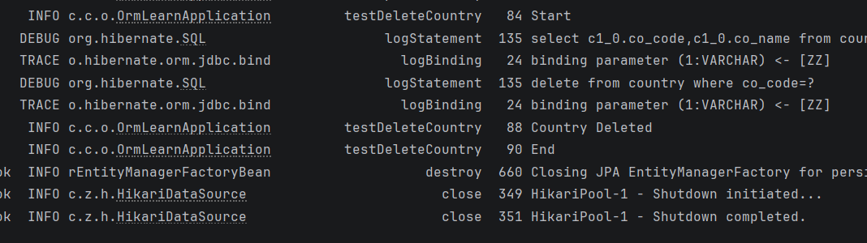

MySQL Workbench Output

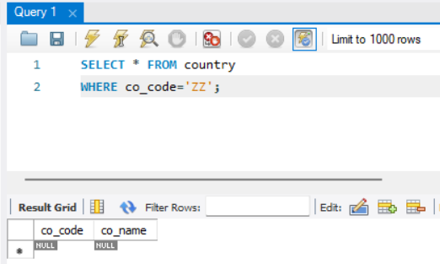

Result
The specified country was successfully deleted from the database.

Conclusion
The deleteById() method effectively removed the entity from the database, demonstrating the delete functionality of Spring Data JPA.

